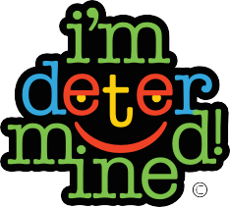
Next Steps to Reach My Goal
Today’s Date:
Name:
People Who Can Support Me to Reach My Goal
Goal Plan
Outcomes
My Goal

Resource provided by I’m Determined, a state-directed project funded by the Virginia Department of Education. © 2006–2018 I’m Determined. All rights reserved. Last updated 01/2018

